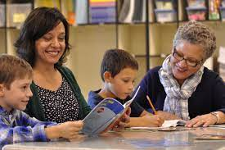
Want to know more about New Hampshire
Paraeducator I and Paraeducator II Certification ?
Feb 3, 2022 4:00 PM
Come join Kimberly Wilson from the NH Department of Education’s Bureau of Credentialing as she explains the processes and requirements for being certificated as a Paraeducator I and Paraeducator II in New Hampshire.
To register for this free workshop presented on the Zoom platform, click on the following link:
https://neanh.zoom.us/meeting/register/tZErc-igqzwsHtUaaVk_JJEfJGj1QR24ogc8
After registering, you will receive a confirmation email containing information about joining the workshop.

